

GUILDWARS 2 Dragons Stand Meta North Lane Guide

Things you need to know about the North Lane of Dragon Stands Meta.

By Nersyss AKA Marta

Guardian of the united[gotu] & Exodus/z of the elder dragons/z[GODS]   EU based

**North Lane xx:30**

**IMPORTANT**

* **NORTH BOSS - Legendary Stavemaster Adryn:** creates portals, imprisons players, AoE attacks, high damage. Needs CC
* **Do not CC the Mouth of Mordremoth.** If as minimal CC as possible you can 1 Shot the boss with high DPS

**EVENTS x2**

**- Glide up to gather Mordrem vine pods and return them to Briallen (arrow, circle, heart):** You have to use the Updrafts to glide to the floating islands and gather pods, bring them to the NPC. There’re some tendrils near the pods.

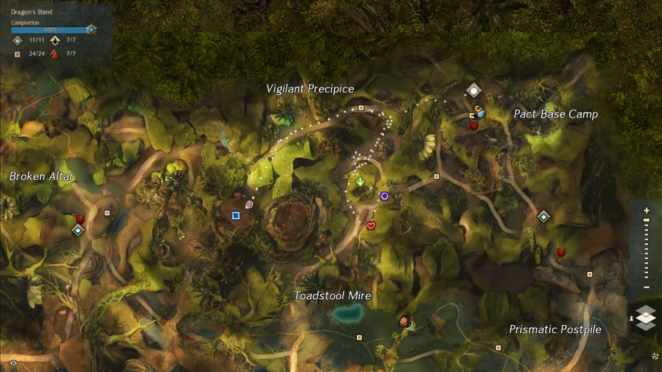**- Bring Chakata shiny wyvern crystals to get the skritt to join the fight (square):** It’s a bit away from the First Northern Checkpoint. You start it by interacting with Chakata, located near the exit of the camp. You have to use the Bouncing Mushrooms to gather crystals, bring them to the NPC. There’re some mobs near the crystals.

*You can start the first event and collect one or two pods, and then if enough people is doing it you can start the second one (crystals).*

**ESCORT**

First you will find the Thornheart (*arrow mark*), on the right of the path. If you don’t kill it fast it can slow down the escort. The best way to deal with it is to use heavy CC to break the blue bar.

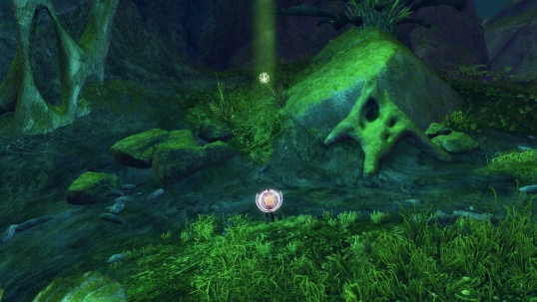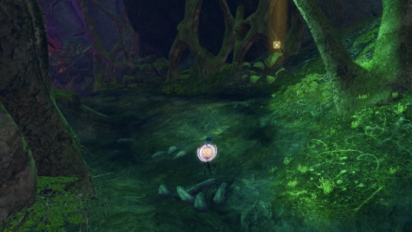After the Thornheart the escort will turn to the right, and there 3 stalkers will spawn, on the right of the path (*X mark*). A little bit xloser to the Spitfire some more mobs will appear. Two of them are Mordrem Cavaliers, with swords above their heads. You have to use a lot of CC at them, or else they will start running and will knock you down, doing a lot of damage.

**SPITFIRE & VINETENDERS**

Here you have to focus on the Wurm Boss and DPS it as soon as the shield disappears. Some Vinetenders will spawn around it, you have to kill them or else they will put the shield on the boss again. They are protected by some mobs.

**EVENTS x2**

**- Bring meat from the saurian nests to build a pile to attract wyverns**: You have to collect meat from the nests and bring it to the NPC. There’re some mobs around the nests.

**- Defend the planted mushrooms until they reach maturity:** Poison Mastery is required. This event is on a cave, it has two entrances: one near the other event and one on the right of the Camp, near a pond. You have to defend some mushrooms while they grow. Kill the mobs and the bombs trying to reach the mushrooms (they appear periodically and are easy to kill).

*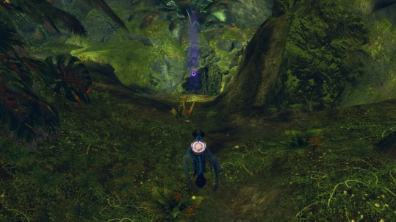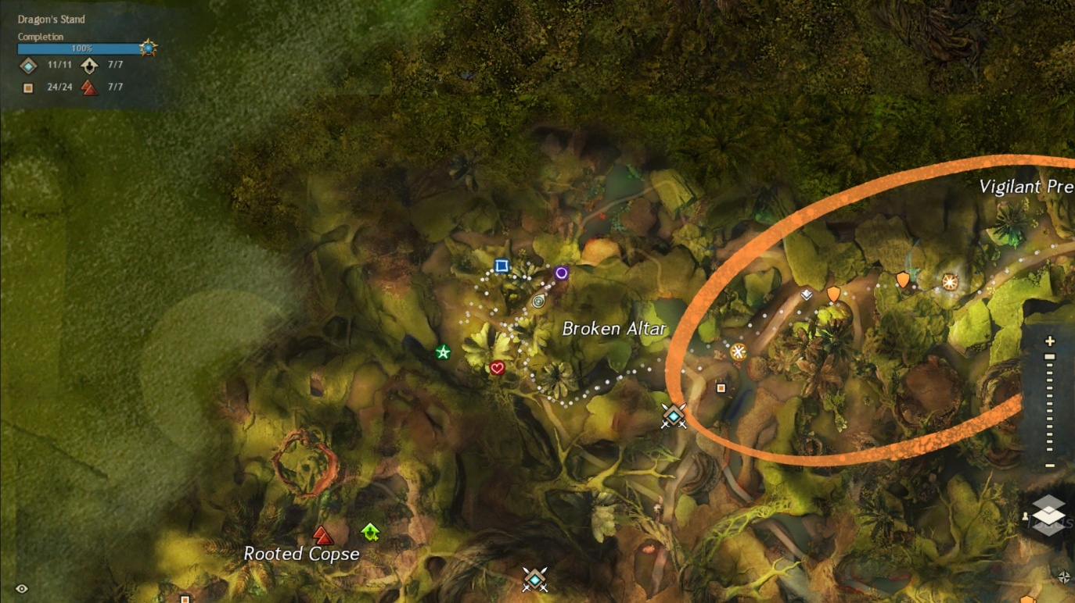You can either divide the squad and do both events at the same time or you can start with collecting the meat. In the second case, when there’s enough people on the nests event you can start the second one, using the entrance near you.*

***Marks****: Nests.*

***Circle****: Underground entrance*

**ESCORT**

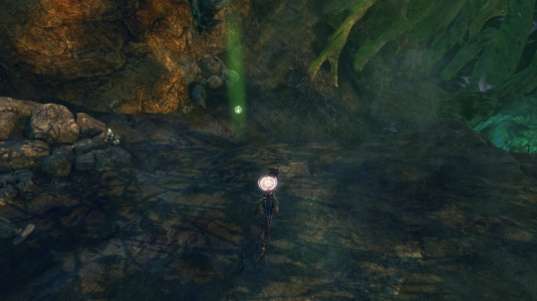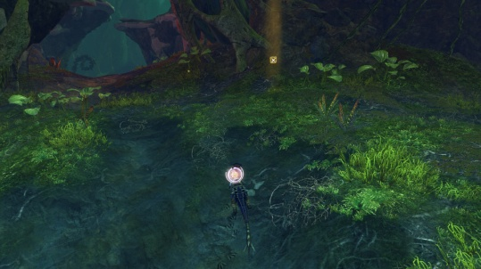Same as before, but his time first you will deal with the Stalkers (*X mark*). Usually near the stalkers is where you also face the Legendary Stavemaster Adryn. After the boss you will find the Thornheart, on the left of the path (*arrow mark*).

**SPITFIRE & PRESERVERS**

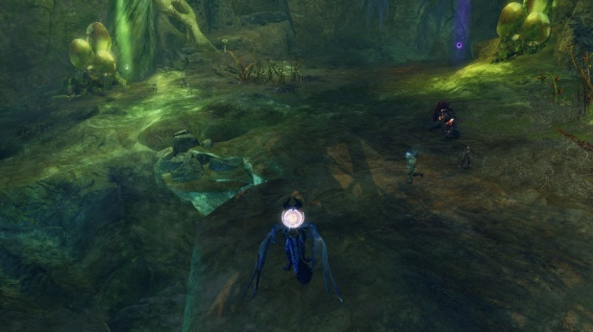After the escort you will face another Spitfire. This time before the boss you have to kill the preservers, which will spawn near it. If they reach the Wurm they will restore its health, so kill them fast. The first one spawns on the left (*arrow mark*), and the second one on the right (*circle mark*). After defeating them use full DPS on the Wurm Boss.

*If you want to try, there’s another option, to kill the Wurm Boss before the preservers reach it, but you need to have a lot of DPS!*

**EVENTS x2**

**- Help Gammalon Vineripper destroy the brambles and clear a path to the Exalted**: You need to clear the path to the exalted. On the way there you will have to kill some tendrils, then some mobs and then you will reach some vine walls. You have to use herbicide to destroy them. There will also be some vinetenders protecting them with a shield.

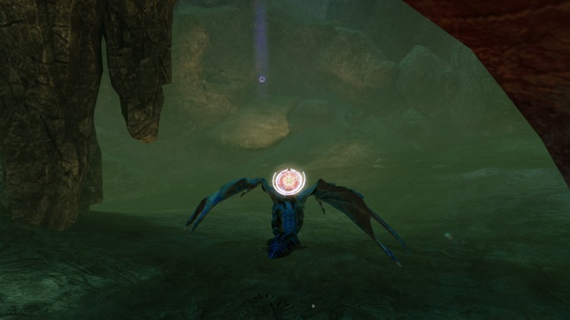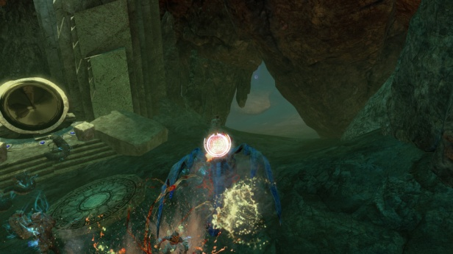**- Help Spleecta turn the Exalted machine back on (circle mark)**: You have to help Spleecta activate some mirrors. Before each mirror some mordrem will spawn, and when activating the mirrors some grubs will also appear. Near the end there is a chest, on a room on the right.

*You can go with the first event (exalted) and when it ends go help the little group with the other one (mirrors), this way all the squad can get the chest.*

**ESCORT**

While waiting for the escort and right after the events usually you have time to go to the tower gate and wait for the Legendary boss to appear. Then you go to the escort. This time the stalkers spawn first, just near the exit of the camp on the left (*X mark*) and then comes the Thornheart on the right of the path, on a little secondary path (*arrow mark*).

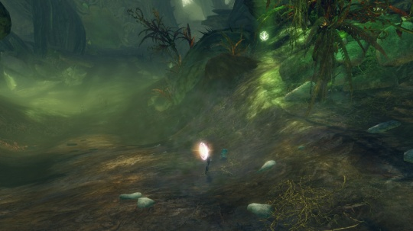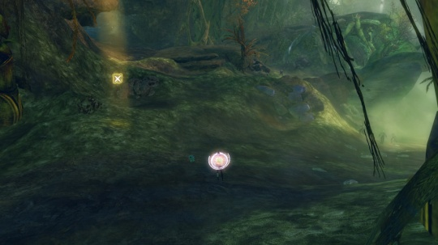If the events are slow the Legendary boss can get to the camp before the escort starts.

**TOWER**

When all the lanes reach the gates the next phase starts. Here you will enter a circular room with a platform in the middle where there is one of the Legendary Bosses. Around the platform 3 Ley Line Pods will spawn; the boss will be invulnerable till you destroy them. Those collectors are protected by 3 preservers that can restore them or even respawn them.

You will need two groups; a little group of around 10 players will go to the middle and kill the Boss, and the main one will follow the commander around the room destroying the collectors and the preservers. Even if the collectors are destroyed the preservers will keep spawning, so the group must keep running and killing them; use CC on them so it’s easier to do so. Full dead players should use the WP since it will be very difficult to revive them, and using swiftness really helps on this phase, a slow rotation can cause the collectors to spawn again. If the collectors respawn the Boss will be invulnerable again, or even revive if it was already killed.

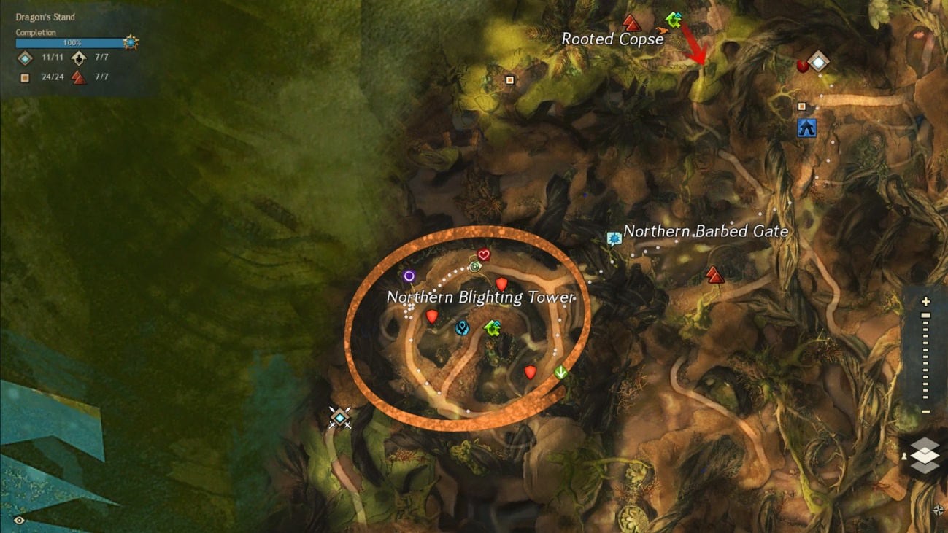

*Shields:* ***Collectors***

*Arrow, circle and heart marks:* ***Preservers’s*** *spawn location*

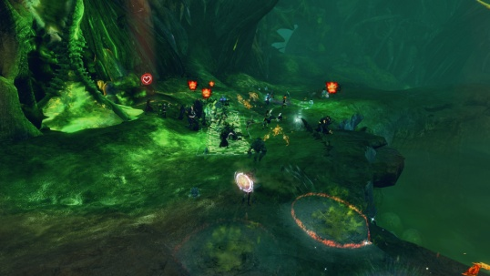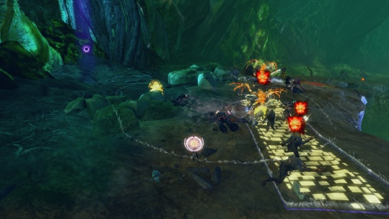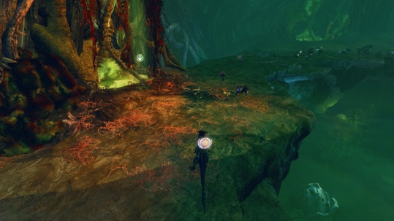

AFTER TOWERS:

**Against the Mouth of Mordremoth**

You will enter a large space of 9 islands, 3 for each lane. The players have to spread across them. The Updraft Mastery is required for this phase, and having Ley Line Gliding mastery makes everything a bit easier since the islands are connected by energy flows.

On this phase you will face different events. In different occasions the **Mouth of Mordremoth's** **head** will attack one island, and at the same time the **dragon’s** **body** will be near another island. Each squad has to go to the nearest. It’s a short attack and you have to be careful with their attacks. The head can do different attacks: fear players, drop bombs or smash the island (for this one look for when the heads goes quite above the island, you have to get off the island or it can instakill you). Some other events that can happen are:

* Destroy the ley-line disruption pods
* Destroy the vine growth: if the event fails a part of the island is destroyed
* Defeat the Mordrem Commanders: the three Legendary Bosses will spawn one on each island.

The important event on this phase is when the Mouth of Mordremoth's head attacks an island and at the same time bombs spawn on another one. The fightwill be longer and is the perfect chance to do as much damage as you can. On this part some bombs spawn on a random island; players near it have to go there and pick one to throw it to the head (don’t throw it when the blue bar is up). Bombs do most of the damage so it’s important to bring as many as possible; you can use the WP to move while holding a bomb. It’s really important not to use CC to have time for the bombs to get to the head.

***Squad chat***

*xx:25 🡪* Mount up until xx:30 so you don’t die. Also at xx:30 map will reset so join fast my instance to get a place into the map. Map will get full fast.

If we end up in a different map than the rest of the Commanders I will swap instances. If that’s the case I will tell.

*1 min left 🡪* Mount up to not die, or use a chair if you have one.

**EVENTS x2**

Use the updraft to gather pods and bring them to the NPC, be careful with tendrils.

Use the bouncing mushrooms to gather crystals, be careful with the mobs.

**ESCORT**

Thornheart will spawn at arrow. Use your bunny. This boss will need a lot of CC at first.

Stalkers will spawn around X mark, kill them fast.

**SPITFIRE & VINETENDERS**

Full DPS the Wurm Boss when it is unshielded. Kill Vinetenders when they spawn, they put a shield on the wurm.

**EVENTS x2**

Bring meat to the pile at arrow.

Go underground, on circle mark. For this event you need poison mastery. Kill the mobs and defend the mushrooms.

**ESCORT**

Stalkers will spawn around X mark, kill them fast.

Thornheart will spawn at arrow. Use your bunny. Remember to use heavy CC on it.

**SPITFIRE & PRESERVERS**

This time we kill preserver first, first arrow and then circle. Then full DPS the Wurm Boss. If the preservers reach the Wurm they will restore it, so we have to kill them fast.

**EVENTS x2**

8-10 players go underground at circle, the rest come with me to escort.

**ESCORT**

Stalkers will spawn around X mark, kill them fast.

Thornheart will spawn at arrow. Use your bunny. Remember to use heavy CC on it.

**TOWER**

For the tower phase we need to kill some preservers (and collectors) and also kill the boss on the middle.

Some volunteers go to group 2 for the boss, max 10. Group 1 with me will rotate and kill preservers. Group 2 after you finish join us or help other lanes if needed.

Group 1: After we killed all collectors use CC for preservers and run fast to make sure they don't reach the zone. Run fast to the point that I mark, don’t wait for me and don’t resurrect fully dead players (use WP).

Group 2: Stack the boss to the middle; don’t let it come to us.

**MOUTH OF MORDREMOTH**

Crowd Control Skills (Cripple, Fear, Taunt, Knockback, Knockdown etc.) Please do not use these skills against Mouth Of Moredemoth. ALL Squads also get the BOMBS; throw them when there is no blue bar.